**TUGAS LAPORAN SEMENTARA**

Nama : Fabyan Yafi Syahbaz

Kelas : 1 D4 Teknik Telekomunikasi C

NRP : 2224600070

1. Coba compile program dibawah ini, jika terjadi error mengapa dan jelaskan!

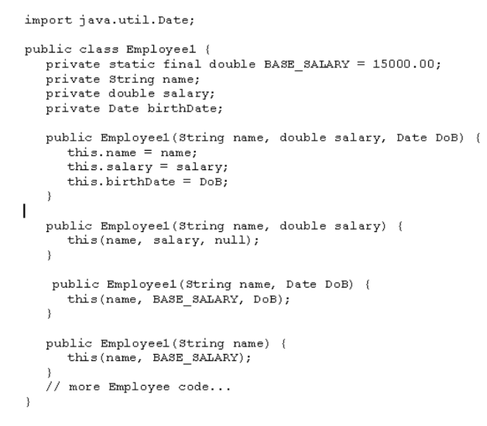

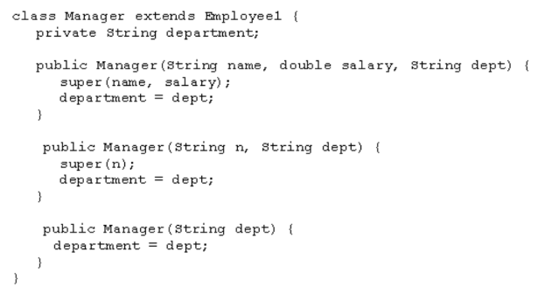

Jawaban : Terjadi kesalahan dikarenakan terdapat kekurangan kode pada public Manager (String dept) yaitu super(null), dimana kode tersebut sebagai pengisi konstruktor pada super class. Selanjutnya mengubah public class Employee1 menjadi super class. Dan menambahkan getinfo() pada class sehingga dapat dipanggil pada kelas utama dan mengeluarkan output.

Perbaikan :

import java.util.Date;

class Employee1 {

    private static final double BASE_SALARY = 15000.00;

    private String name;

    private double salary;

    private Date birthDate;

    public Employee1(String name, double salary, Date DoB) {

        this.name = name;

        this.salary = salary;

        this.birthDate = DoB;

    }

    public Employee1(String name, double salary) {

        this(name, salary, null);

    }

    public Employee1(String name, Date DoB) {

        this(name, BASE_SALARY, DoB);

    }

    public Employee1(String name) {

        this(name, BASE_SALARY);

    }

    public void getinfo(){

        System.out.println("Nama : " + name);

        if (birthDate != null) {

            System.out.println("Tanggal Lahir : " + birthDate);

        } else {

            System.out.print("");

        }

        System.out.println("Gaji Bulanan : " + salary);

    }

}

class Manager extends Employee1 {

    private String department;

    public Manager(String name, double salary, String dept) {

        super(name, salary);

        this.department = dept;

    }

    public Manager (String n, String dept) {

        super(n);

        this.department = dept;

    }

    public Manager (String dept){

        super(null);

        this.department = dept;

    }

    public void getinfo(){

        super.getinfo();

        System.out.println("Department : " + department);

    }

}

public class percobaan1 {

    public static void main(String[] args) {

        Employee1 e = new Employee1("Budi", new Date(2000, 10, 10));

        Manager m = new Manager("Andi", 20000, "Telkom");

        e.getinfo();

        m.getinfo();

    }

}

Output :

Nama : Budi

Tanggal Lahir : Sat Nov 10 00:00:00 GMT+07:00 3900

Gaji Bulanan : 15000.0

Nama : Andi

Gaji Bulanan : 20000.0

Department : Telkom

1. mengimplementasikan UML class diagram dalam program untuk class bentuk

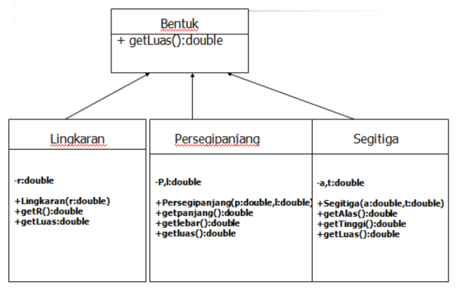

Jawaban :

abstract class Bentuk {

    public abstract double getLuas();

}

class Lingkaran extends Bentuk {

    private double r;

    public Lingkaran(double r){

        this.r = r;

    }

    public double getR(){

        return r;

    }

    public double getLuas(){

        return 3.14 * r * r;

    }

}

class Persegipanjang extends Bentuk {

    private double p;

    private double l;

    public Persegipanjang(double p, double l){

        this.p = p;

        this.l = l;

    }

    public double getpanjang(){

        return p;

    }

    public double getlebar(){

        return l;

    }

    public double getLuas(){

        return p * l;

    }

}

class Segitiga extends Bentuk {

    private double a;

    private double t;

    public Segitiga(double a, double t){

        this.a = a;

        this.t = t;

    }

    public double getAlas(){

        return a;

    }

    public double getTinggi(){

        return t;

    }

    public double getLuas(){

        return 0.5 * a * t;

    }

}

public class percobaan2 {

    public static void main(String[] args) {

        Lingkaran l = new Lingkaran(10);

        Persegipanjang p = new Persegipanjang(5, 4);

        Segitiga s = new Segitiga(6, 7);

        System.out.println("Luas Lingkaran : " + l.getLuas());

        System.out.println("Luas Persegi Panjang : " + p.getLuas());

        System.out.println("Luas Segitiga : " + s.getLuas());

    }

}

Output :

Luas Lingkaran : 314.0

Luas Persegi Panjang : 20.0

Luas Segitiga : 21.0

1. mengimplementasikan UML class diagram dalam program

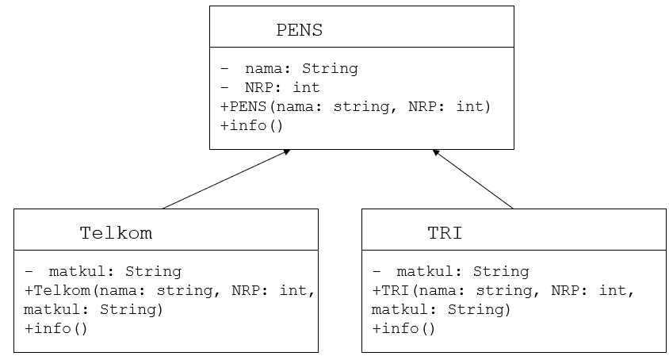

Jawaban :

class PENS{

    private String nama;

    private int NRP;

    public PENS(String nama, int NRP){

        this.nama = nama;

        this.NRP = NRP;

    }

    public void info(){

        System.out.println("Nama : " + nama);

        System.out.println("NRP : " + NRP);

    }

}

class Telkom extends PENS{

    private String matkul;

    public Telkom(String nama, int NRP, String matkul){

        super(nama, NRP);

        this.matkul = matkul;

    }

    public void info(){

        super.info();

        System.out.println("Prodi : " + matkul);

    }

}

class TRI extends PENS{

    private String matkul;

    public TRI(String nama, int NRP, String matkul){

        super(nama, NRP);

        this.matkul = matkul;

    }

    public void info(){

        super.info();

        System.out.println("Prodi : " + matkul);

    }

}

public class percobaan3 {

    public static void main(String[] args) {

        Telkom t = new Telkom("Andi", 062, "Elektromagnetika");

        TRI tr = new TRI("Budi", 124, "Matematika");

        t.info();

        tr.info();

    }

}

Output :

Nama : Andi

NRP : 50

Prodi : Elektromagnetika

Nama : Budi

NRP : 124

Prodi : Matematika